Date: |  | Harness Specification Sheet  Customer Notes:
Dealer Name: |  | Customer Notes:
Customer Name:
Daytime Contact No:
Email Address:
Approval Type: | Qty required: | Colour:

Make of Vehicle: | Type: | Year:

Shoulder strap measurements “A” should be taken with driver seated in vehicle with harness fastened tight.
TRS Technical Tip: Shoulder measurements “A” under 65cm TRS recommend a Sewn Bearing Point
Sewn Bearing Point | Threaded Anchor Point with 3 Bar Slide |  | Shoulder Webbing Width:  FHR Specific 50mm  75mm | Length A: cm  Measure distance “A” from centre of anchor mounting point to centre of adjuster
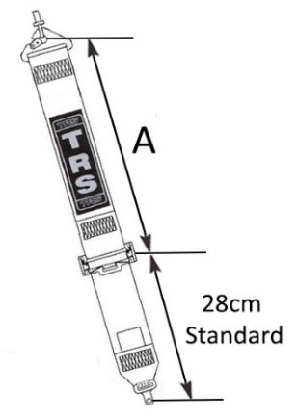 | 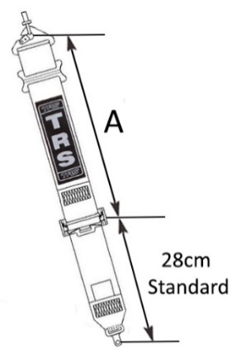 |  | 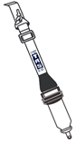
Shoulder Adjuster (Mark appropriate box)
TRS Technical Tip: TRS Recommend the aluminium adjuster for fast and easy adjustment
75mm Steel Adjuster |  | 75mm Aluminium Adjuster
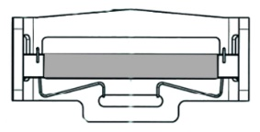

Lap Straps - Measurements should be taken with the harness fastened tight and adjustment in midway position.
“B” is 50cm as standard from centre of anchor mounting to centre of release buckle.
“C” is 12cm as standard from centre of mounting strap to centre of adjuster.
Single Seater Lap  (STD) |  | 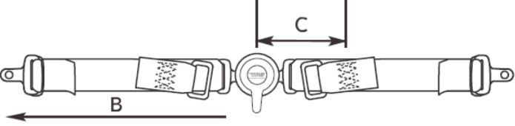 | Length B:  (Overall Length)  Length C:  (12cm STD) | cm  cm
Pull Up  (with aluminium adjusters) |  | 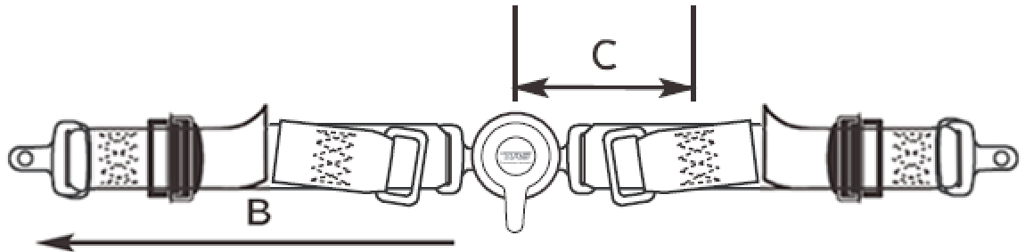 | Length B:  (Overall Length)  Length C:  (12cm STD) | cm  cm
Pull Down  (with aluminium adjusters) |  | 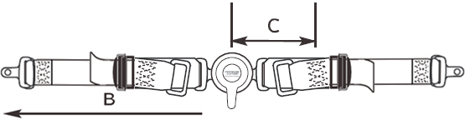 | Length B:  (Overall Length)  Length C:  (12cm STD) | cm  cm
Lap Adjuster
TRS Technical Tip: TRS Recommend the aluminium adjuster for fast and easy adjustment
50mm Aluminium Adjuster

Rotary Quick Release Buckle Only
Permanently fixed to right hand lap strap (Standard for single seater or 4 point saloon)
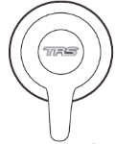

50mm Crutch Straps - Measurements should be taken with the driver seated in the vehicle.
Single Seater Crutch
“D” is 65cm as standard.
Pull Down |  | 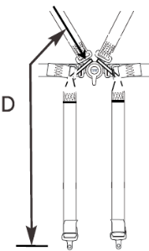 | Length D: | cm

 | Sewn Anchorages - Mark appropriate boxes to identify requirements
Sewn Snap Hook | Sewn 8mm Bolt in Plate | Sewn 9.5mm Bolt in Plate | Sewn 11mm Bolt in Plate | Sewn 13mm Bolt in Plate | Sewn 15mm Bolt in Plate | Sewn Flat Loop  4cm is standard | Sewn Pinched Becket
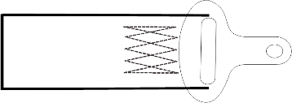  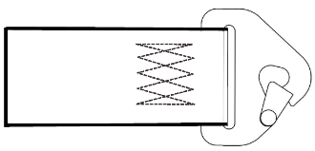 |  | 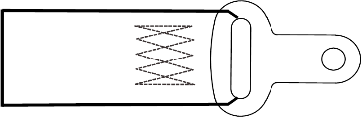 | 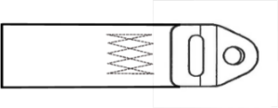 | 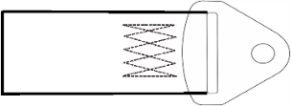 | 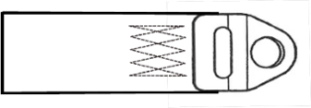 |  | 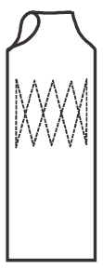
FHR 50mm
Shoulder Straps
75mm
Shoulder Straps
 |  |  |  |  |  |  |  | 50mm Lap Straps

Threaded Anchorages - Mark appropriate boxes to identify requirements
Snap Hook + 3 Bar Slide | 13mm Bolt in Plate + 3 Bar Slide | 8mm Bolt in Plates as Pinch Plates | 13mm Bolt in Plates as Pinch Plates | 10mm Bolt in Plates as Pinch Plates
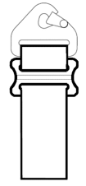 | 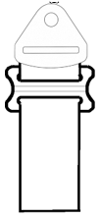
FHR 50mm
Shoulder Straps
75mm
Shoulder Straps
50mm Lap
Straps
 |  |  |  |  | 50mm Crutch Straps

