Date: |  | Harness Specification Sheet  Customer Notes:
Dealer Name: |  | Customer Notes:
Customer Name:
Daytime Contact No:
Email Address:
Approval Type: | Qty required: | Colour:

Make of Vehicle: | Type: | Year:

Shoulder strap measurements “A” should be taken with driver seated in vehicle with harness fastened tight.
TRS Technical Tip: Shoulder measurements “A” under 65cm TRS recommend a Sewn Bearing Point
Sewn Bearing Point | Threaded Anchor Point with 3 Bar Slide |  | Length A: cm  Measure distance “A” from centre of anchor mounting point to centre of adjuster
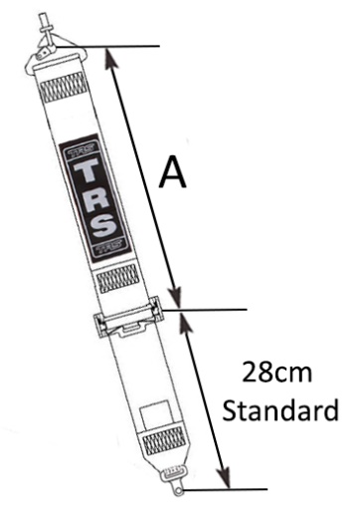 | 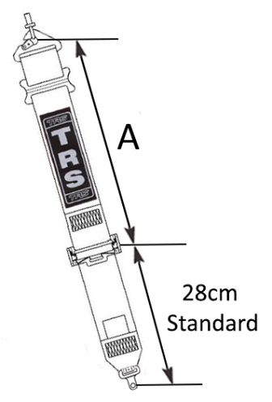
Shoulder Adjuster (Mark appropriate box)
TRS Technical Tip: TRS Recommend the aluminium adjuster for fast and easy adjustment
50mm Steel Adjuster |  | 50mm Aluminium Adjuster
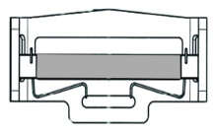

Lap Straps - Measurements should be taken with the harness fastened tight and adjustment in midway position.
“B” is 65cm as standard from centre of anchor mounting to centre of release buckle.
“C” is 12cm as standard from centre of mounting strap to centre of adjuster.
Pull Up  (STD Direction) |  | 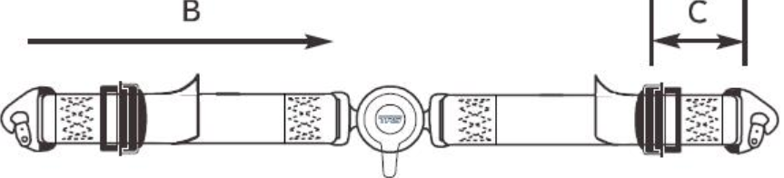 |  |  | Length B:  (Overall Length)  Length C:  (Adjuster Length) | cm  cm
Pull Down  (Suited for tight cockpits i.e. Kit Car) |  | 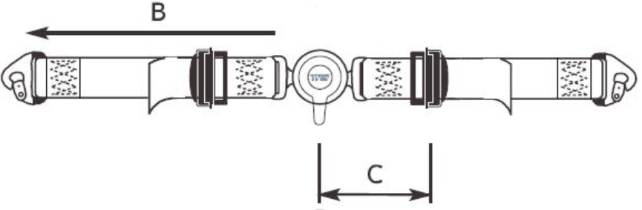 |  |  | Length B:  (Overall Length)  Length C:  (Adjuster Length) | cm  cm
Lap Adjuster (Mark appropriate box)
TRS Technical Tip: TRS Recommend the aluminium adjuster for fast and easy adjustment
50mm Steel Adjuster |  |  | 50mm Aluminium Adjuster | 50mm Integrated Enduro  Quick Adjuster
 |  |  |  | 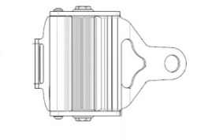

Rotary Quick Release Buckle Only
Permanently fixed to Crotch Strap M10-0003 (Standard for a 5pt/6pt Saloon)
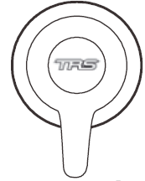

50mm Crutch Straps - Measurements should be taken with the driver seated in the vehicle.
2-point Crutch Moustache
“D” is 65cm as standard.
Pull Down |  | 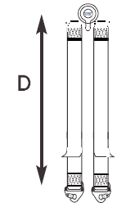 | Length D: | cm

Sewn Anchorages - Mark appropriate boxes to identify requirements
Sewn Snap Hook | Sewn 9.5mm Bolt in Plate | Sewn 11mm Bolt in Plate | Sewn 15mm Bolt in Plate | Sewn Flat Loop  4cm is standard | Porsche Anchor Plate
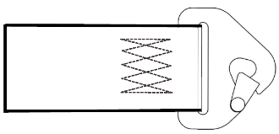 | 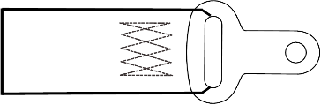 | 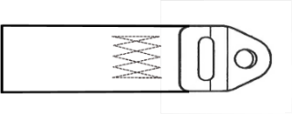 | 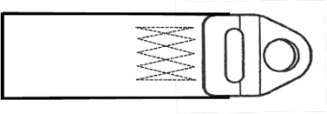 | 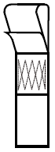 | 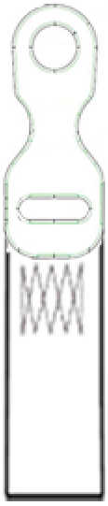
FHR 50mm
Shoulder Straps Straps
 |  |  |  |  |  | 50mm Lap Straps

Threaded Anchorages - Mark appropriate boxes to identify requirements
Snap Hook + 3 Bar Slide | 13mm Bolt in Plate + 3 Bar Slide | Wrap Around | 8mm Bolt in Plates as Pinch Plates
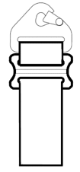 | 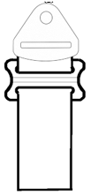 |  | 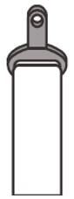
FHR 50mm
Shoulder Straps
50mm Lap
Straps
 |  |  |  | 50mm Crutch Straps

