Date: |  | Harness Specification Sheet  Customer Notes:
Dealer Name: |  | Customer Notes:
Customer Name:
Daytime Contact No:
Email Address:
Approval Type: | Qty required: | Colour:

Make of Vehicle: | Type: | Year:

Shoulder strap measurements “A” should be taken with driver seated in vehicle with harness fastened tight.
TRS Technical Tip: Shoulder measurements “A” under 65cm TRS recommend a Sewn Bearing Point
Sewn Bearing Point | Threaded Anchor Point with 3 Bar Slide |  | Length A: cm  Measure distance “A” from centre of anchor mounting point to centre of adjuster
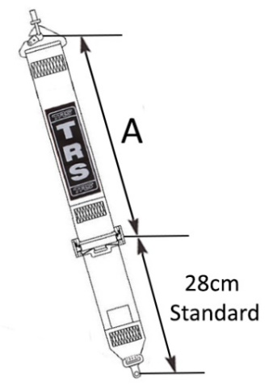 | 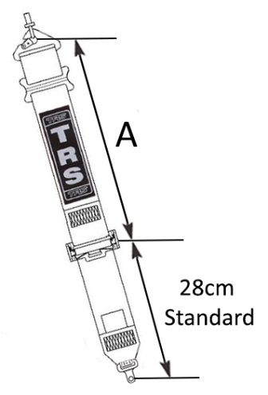
Shoulder Adjuster (Mark appropriate box)
TRS Technical Tip: TRS Recommend the aluminium adjuster for fast and easy adjustment
50mm Steel Adjuster |  | 50mm Aluminium Adjuster
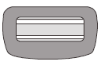

Lap Straps - Measurements should be taken with the harness fastened tight and adjustment in midway position.
“B” is 65cm as standard from centre of anchor mounting to centre of release buckle.
“C” is 12cm as standard from centre of mounting strap to centre of adjuster.
Pull Up  (STD Direction) |  | 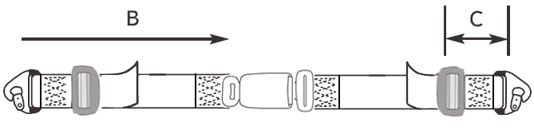 |  | Length B:  (Overall Length)  Length C:  (Adjuster Length) | cm  cm
Pull Down  (Suited for tight cockpits i.e. Kit Car) |  | 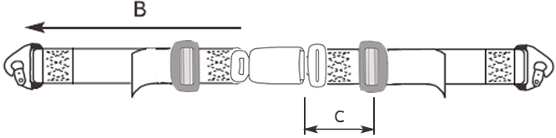 |  | Length B:  (Overall Length)  Length C:  (Adjuster Length) | cm  cm
Lap Adjuster (Mark appropriate box)
TRS Technical Tip: TRS Recommend the aluminium adjuster for fast and easy adjustment
50mm Steel Adjuster |  |  | 50mm Aluminium Adjuster

Press Release Buckle Only
Permanently fixed to right hand lap strap (Standard for 4pt road ece harnesses)
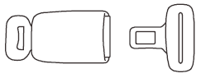

Sewn Anchorages - Mark appropriate boxes to identify requirements
Sewn Snap Hook | Sewn 11mm Bolt in Plate | Sewn 15mm Bolt in Plate
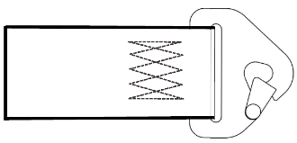 | 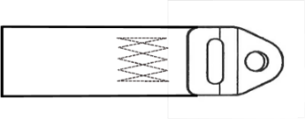 | 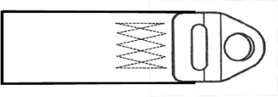
 |  |  | Shoulder Straps
 |  |  | Lap Straps

Threaded Anchorages - Mark appropriate boxes to identify requirements
Snap Hook + 3 Bar Slide | 11mm Bolt in Plate + 3 Bar Slide | 15mm Bolt in Plate + 3 Bar Slide | Wrap Around
 | 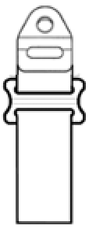 | 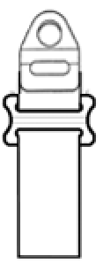
 |  |  |  | Shoulder Straps
 |  |  |  | Lap Straps

