Motorsport Safety Equipment
www.trs-motorsport.com | +44 (0) 1302 750800 | sales@trs-motorsport.com

Benefits of TRS’ Aluminium Adjusters
Motorsport Safety Equipment
www.trs-motorsport.com | +44 (0) 1302750800 | sales@trs-motorsport.com

TRS Aluminium Adjusters
- FIA approved 8854:98 and 8853:2016
- Professional smooth-running aluminium adjuster
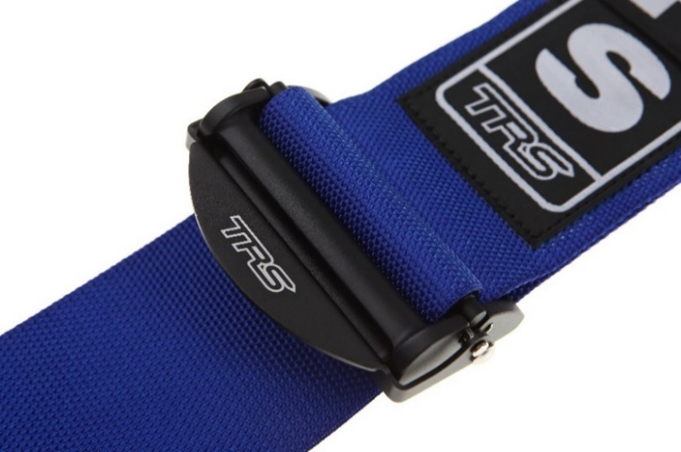
- 75mm and 50mm versions
- 40% lighter than steel adjusters
- Super-fast adjustment
- Perfect choice for easy driver changes
- FHR friendly

The aluminium adjuster is probably the biggest advancement in harness technology since harnesses were invented.

History:
Aluminium adjusters were initially developed for aircraft fighter pilots who demanded ease of use, lightness, and strength from their aviation harnesses. TRS quickly recognized that these advantages would massively benefit the motorsport driver too. TRS were one of the first motorsport harness manufacturers to introduce the aluminium adjusters into race and rally cars.
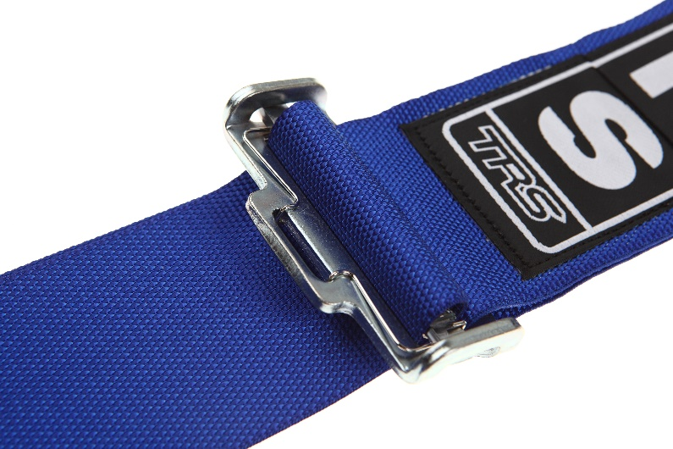
Specification:
Manufactured from forged aluminium the smooth-running alloy adjusters are finished in an attractive anodized black finish. The forged aluminium adjusters exceed the FIA's load requirements by over 150% and are 40% lighter than a standard steel adjuster. Aluminium adjusters offer exceptional strength, quality, lightness, and ease of use.

Ease of Use:
The clever geometry of the lever and release bar make the aluminium adjuster very easy to use. First time users of alloy adjusters always enthuse how easy they are to adjust, pull tight and loosen off - remarking that they are now in total control of adjusting their harness. It is a massive step forward from the conventional steel adjuster and users say they would never revert to the standard steel adjuster once they experience how good they are.

Motorsport Safety Equipment
www.trs-motorsport.com | +44 (0) 1302750800 | sales@trs-motorsport.com

Aluminium Adjusters

Areas of Use:
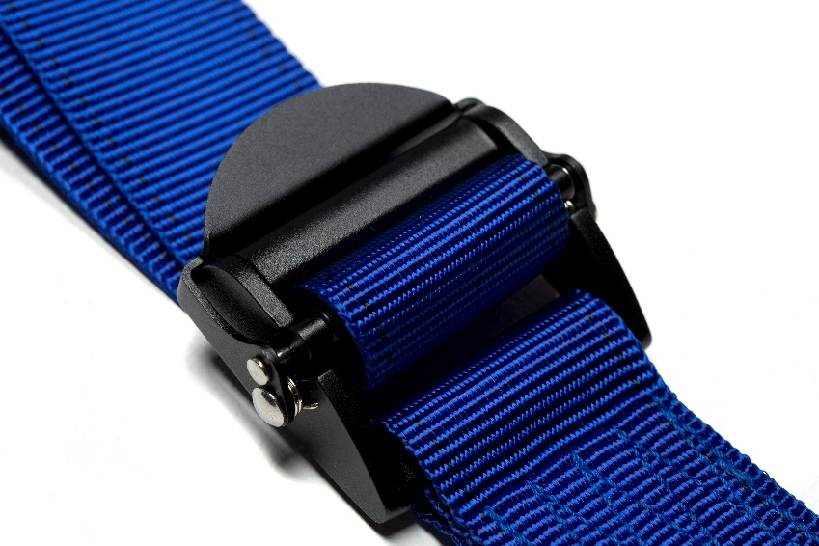
Aluminium adjusters are used on the shoulder straps and lap straps. Some drivers choose only to use alloy adjusters on the shoulder straps. This type of harness is called a Superlite harness and is our mid-range harness. It is a great value harness, especially for rally drivers and co drivers who are in and out of the car a lot during stages and need fast and easy adjustment on the shoulder straps. Co driver's especially like the ease of use at the end of stage, being able to loosen off the belts to put away pace notes while still having the security of being strapped in.

Most drivers prefer to have alloy adjusters on both the shoulder straps and lap straps. This type of harness is called an Ultralite harness and is our top of the range harness. It is used by drivers competing in race, rally, Hillclimb, sprint, drift, drag, track day and military environments. It is very popular with endurance racers who are required to make driver changes during the race and need fast and easy adjustment of both the shoulder and lap straps - crucial when you have different shape and size drivers!

50mm Aluminium Shoulder and Pelvic Lap Straps:
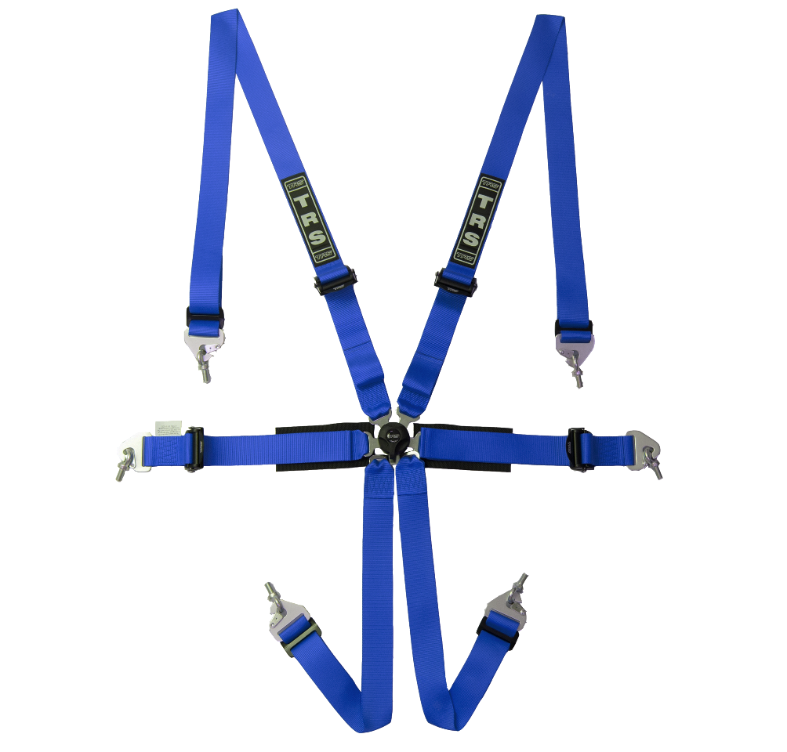
Shoulder and pelvic lap straps can be manufactured with either a 75mm or 50mm aluminium adjuster. 50mm adjusters are very useful for cockpits where space is at a premium and there is not enough room for a 75mm adjuster. Lap straps can be manufactured in the conventional pull up to tighten style or reversed to a pull down to tighten format. Please specify at point of order with your supplying distributor which direction of adjustment best suits your car.

Motorsport Safety Equipment
www.trs-motorsport.com | +44 (0) 1302 750800 | sales@trs-motorsport.com

